GENERAL INTRODUCTION TO PRUNING FRUIT TREES
Prepared by Mike Chase as a synthesis of information presented in Agricultural Bulletins on Pruning

The three-hour in-orchard demonstration will deal with specifics of pruning various kinds of fruit trees at various stages in their development. In preparation for the in-orchard demonstration please read the background material below that will orient you to what you will be seeing and hearing during the demonstrations.

Goals of Pruning – “Begin with the end in mind” (Stephen Covey)
There are several important goals we hope to achieve in our pruning program. These include:
1. Shape/structure): Pruning cuts made in the first three training years are crucial to the proper development of a tree conforming to structural option (open vase, central leader, slender spindle, etc.) selected for a particular variety of fruit tree. The structure of our trees in turn plays an important role in achieving several of the other goals listed below.
2. Encouraging early fruiting and spur development: Restraint on number of cuts made on young trees contributes to early bearing. Other cultural practices such as spreading limbs also contributes to greater fruit spur development.
3. Establishing overall size: Some people like tall and wide trees because they can carry more fruit per tree. Others limit the size of the tree for various reasons (ease of harvesting, spraying, etc.). Although other factors influence tree size (dwarfing root stock, soil fertility, etc.), pruning is key to achieving the desired tree size (especially summer pruning).
4. Sunlight penetration: Leaf surface is reduced by pruning, but it is necessary to allow sunlight to penetrate into the tree to produce the carbohydrates and energy that enable the growth of roots, shoots and fruit. In addition to the production of the current season’s fruit and maximizing the health of the fruiting spurs, sunlight penetration during the growing season is also key to next season’s flower bud production and crop.
5. Air circulation: Trees prosper when they have a good balance of as much leaf surface as possible, yet adequate pruning of the interior for better air circulation which reduces humidity and allows for better coverage of pesticides.
6. Structural strength: Pruning is used to select which branches are kept as scaffold limbs (angle and location being major factors) on the main trunk. Pruning is also used to strengthen fruit-bearing branches by cutting back so as not to overload the ends of branches, leading to downward-sloping limbs and broken branches.
7. Development of laterals and fruit buds: Pruning is used to select the laterals and fruit buds that will bear the current year’s crop and also set up the development of fruit buds for future years.
8. Production: Pruning is done to maintain the optimum balance between vegetative growth, flower production and fruiting. Dormant pruning is a reliable crop load management tool.
9. Regulating vigor: Dormant pruning is an invigorating process that stimulates vegetative growth while summer pruning is a devigorating process that reduces growth because it involves removing part of the functional leaf area of the tree. Pruning is one of the methods of ensuring proper annual growth and renewal (e.g., use of the bench cut on some varieties).
Question: Which is more important: shape/structure, early fruiting, overall size, sunlight penetration, air circulation, structural strength, development of laterals and fruit buds, production, regulating vigor? Answer: All are important!

Note about production and the regulation of vigor:
Before going on to practical issues related to proper pruning it will be helpful to provide a big-picture view of the interplay of several elements related to tree vigor (the issue in #8 and #9 above):
Within a tree that has a healthy leaf canopy producing photosynthates, there is a competition between shoot (new visible growth), root (development of the underground storage system for food produced above ground in the leaves), and fruit growth (including the setting of new fruit buds). There are three possible situations:
- Low-vigor tree – loss of fruitfulness, small sized fruits due to over-cropping, poor or irregular fertilization and watering.
- High-vigor tree – a response to loss of crop, severe pruning, or over-fertilization.
- Moderate-vigor tree – the ideal of moderate crops of good-sized fruit.

Pruning practices are a key factor in the maintenance of an appropriate level of tree vigor to carry out the fruit production task.

Structure Options
There are two tree structure options commonly found in commercial orchards (e.g., Green Bluff and the Spokane Valley) and home orchards in the Spokane area: the open vase (or open center) and the central leader (or pyramid) and its variant, the modified central leader. Until recently, these were also the most common structures found in the commercial orchards in the central part of our state and in the fruit growing regions of Oregon and Idaho. Since these are so common they will be the focus of this seminar. If you have established fruit trees in your backyard, more than likely they are being trained with one of these two methods.

However, I want to also draw your attention to major changes in tree structure taking place in commercial orchards across the center of our state, in Oregon, and in Idaho, and also a major difference in perspective between home orchards in the US and those in Great Britain. If you are a commercial orchardist, it is very likely that your new planting of apple trees might be using one of these systems in addition to continuing to use the central leader: Bi-axis, Slender spindle, Superspindle/vertical axis, Tatura trellis or V system, Vertical Axis. If you are putting in a new planting of pears you might use the older central leader system, but you might also be considering Bi-axis, Multi-Leader, or Slender Spindle. And if you were putting in a new cherry block you might be considering the Kym Green Bush (KGB), Steep Leader, Tall Spindle Axis, Upright Fruiting Offshoots (UFO), Vogel Central Leader, Spanish Bush, Super Slender Axis (SSA), in addition to the older central leader structure.

Although it is beyond the scope of this seminar to go into details on any of these new systems, it should be noted that many of those “new” ways of structuring fruit trees being used in new fruit tree plantings in the commercial fruit growing areas of Washington, Oregon, and Idaho can be found in home orchards all through Great Britain and other parts of Europe and have been in use there for decades. My favorite pruning book, How to Prune Fruiting Plants by Richard Bird, provides a really good introduction because of the illustrations that show both dormant and summer cuts to control tree size and shape.

Perhaps what I have said above creates a little tension in you about spending time in this seminar learning skills to prune open vase and central leader trees when they appear to becoming a thing of the past. Don’t worry, everything you learn in this seminar you would be able apply to adopting one of these new methods of training fruit trees. Happily, the theory behind making pruning cuts applies to all shapes of trees. Thus, the content of this seminar will help you better maintain your existing open vase and central leader trees, as well as train any new trees in using any of these new methods. For example, I’m planting some new cherries. Some will be trained using the Spanish Bush system and others will be trained using the Kym Green Bush system. I’m excited about this because it helps me maintain the trees at a height that I can cover the trees to protect from birds. I’ll also be putting in a couple of pears that I will be using the slender spindle with. I’m also planning to redesign a couple of unruly pears into a slender spindle. When you know the basic dynamics of pruning cuts (the cause-and-effect relationships), you can use those principles to train and maintain a tree using any of these new alternatives to the open vase and central leader.

To the right are stylized depictions of the central leader, modified central leader, and the open center (vase) structures. Ideally, the central leader tree is in the shape of a cone or Christmas tree, allowing for maximum light to get to fruiting areas. The scaffolds are shorter than on an open center tree and are hence stronger. The modified central leader is often used where trees are unruly and don’t want to conform to central leader training (e.g., pears, European plums, and cherries). The open center is used with most stone fruit (e.g., peaches, apricots, plums, and cherries). | 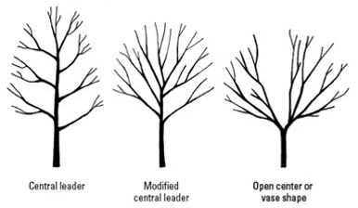

Central Leader Structure
Below are the first 5 years in the making of a new central leader fruit tree. The spreading sticks are used early in the development of a central leader tree to get its scaffold limbs to spread out to form 45 - 60 degree angled branches. The dashed lines depict the limbs that naturally form but are removed to keep the structure open for light penetration which is essential to the health of fruiting spurs and fruit.
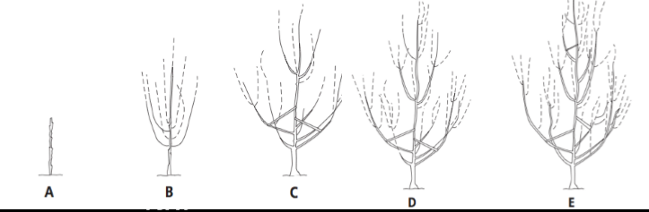

Open Center Structure  Over to the right is a diagram of a view from above of an open center fruit tree showing that, over 3 years, even though only three or four scaffolds were originally selected, these in turn have a branching pattern that enables an open center tree to have a lot of length on which to grow smaller lateral limbs that carry fruit spurs and fruit. It is important to select your scaffolds that radiate out form the trunk at different heights. Scaffold branches that are opposite one another on the trunk are very weak in comparison to ones that are 6 to 8 inches apart on the trunk. “D” down below shows a side view of the young open center tree. | 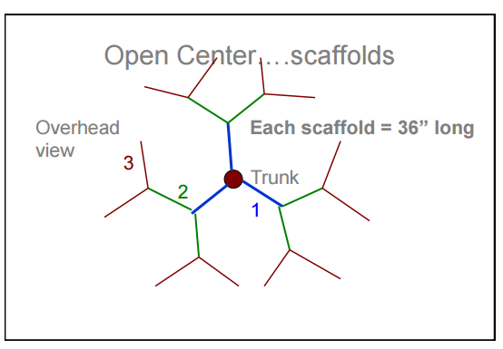
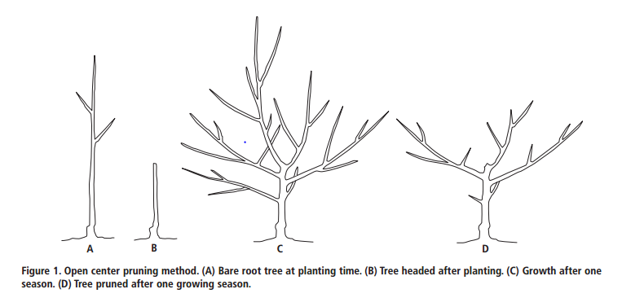
Study “D.” Then draw lines on “C” representing the cuts that the orchardist made, shortening or removing branches.

Bush Structure
Because many of the newer, small tree structures being used in commercial orchards in the Northwest and found in Richard Bird’s pruning books are some variation of the bush, a short description of the bush structure is provided here. The text and diagram below are from University of California Publication 8057, Fruit Trees: Training and Pruning Deciduous Trees (http://anrcatlog.ucdavis.edu).

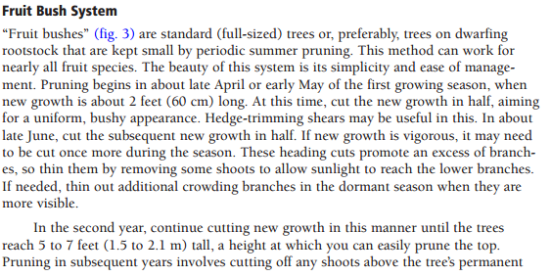
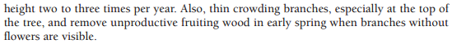
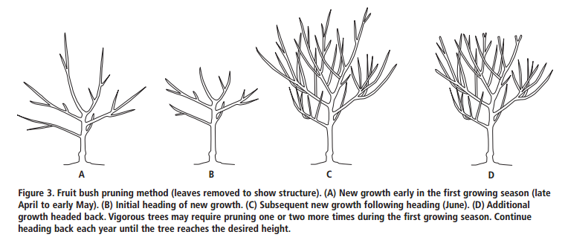

The Mechanics of Pruning
If the cuts are in small diameter wood the depiction to the right describes the correct angle and location of the cut with respect to the closest bud. The reason for care in making these cuts is to minimize damage from the cut and to speed healing of the wound. A speedy recovery is important to avoid diseases entering through the cut. | 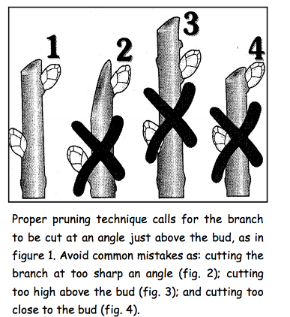

If cuts are made in larger limbs where there is a risk of tearing the bark below the cut then the limb is cut in two steps as depicted to the right.  #1 and #2 cuts allow you to remove the larger branch and get it out of the way before working on the short (light) section that remains.  It is really important not to do a “flush cut” because it damages the branch collar and slows healing. It is also important not to leave a stub because it doesn’t heal over. See picture below of three examples of properly healed large cuts that followed the guidelines give in the diagram to the right. The proper location for the cut is just to the outside of the branch collar.  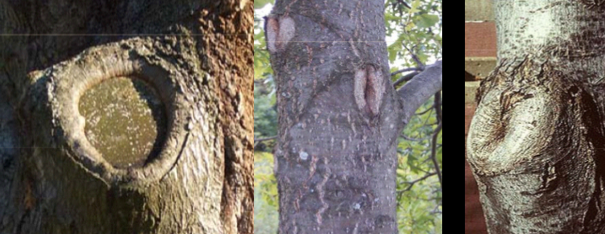 | 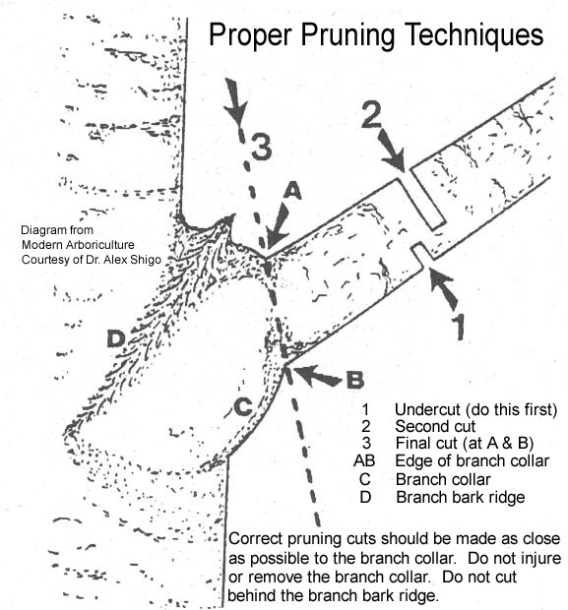

Types of Cuts

Thinning Cut The thinning cut removes a branch or lateral back to its point of origin. Thinning cuts do not overstimulate the tree like a heading cut tends to do. The thinning cut is used to open a tree up for better light penetration.  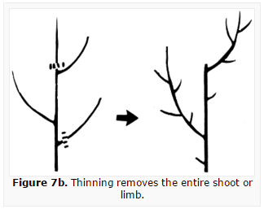 | 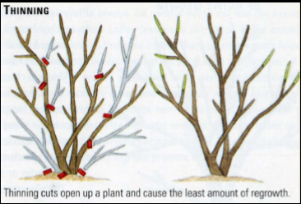
In Figure 7b, can you see what growth was stimulated in the following year after the thinning cuts were made?

Heading Cut The heading cut is used to remove the tip of a branch to a side lateral or bud. This cut is used to redirect growth and to initiate lateral bud break below the cut. Thus, a heading cut tends to increase vegetative growth just below the cut.  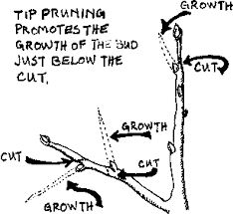 | 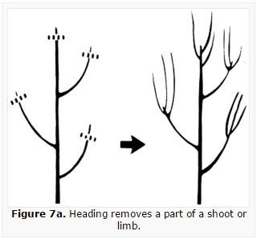
In Figure 7a, can you see the changes related to the previous year’s heading cuts?

Bench Cut Much less common than heading cuts which are done at branch tips, is the bench cut which is done directly after the first bud nearest the trunk on a failing structural lateral. The purpose is to create a replacement structural lateral.

Bevel Cut (aka Dutch Cut) Also uncommon. This cut involves the removal of a limb to just outside the branch collar, at an angle, not flush to the collar. This technique is used to create a replacement scaffold that will develop just under the cut with a wide crotch angle.
Physiology of Tree Growth & Implications for Pruning

Branch Angle
The chart to the right shows the response to branch angle. Note for example that vertical branches tend not to set fruit. This is why branches are pushed out to a more horizontal orientation with spacers or tied to make them more horizontal to induce earlier bearing.  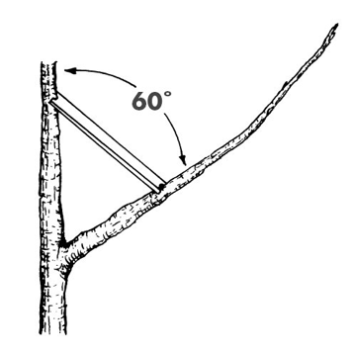 | 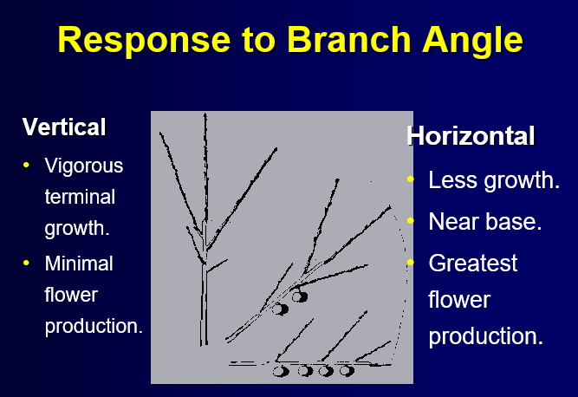

Tree Support for Young Trees  - Un-staked trees require more pruning.  - The movement in un-staked trees causes minute damage to cells and trunk tissue (stress -> ethylene -> lateral cell growth).  - Tree puts resources into shoot growth instead of fruit buds.  - Tree support reduces stress on graft union.  - Tree support maintains upright positon of central leader.  - Mature trees that lean are not as strong as those that are upright (give them a good start) | 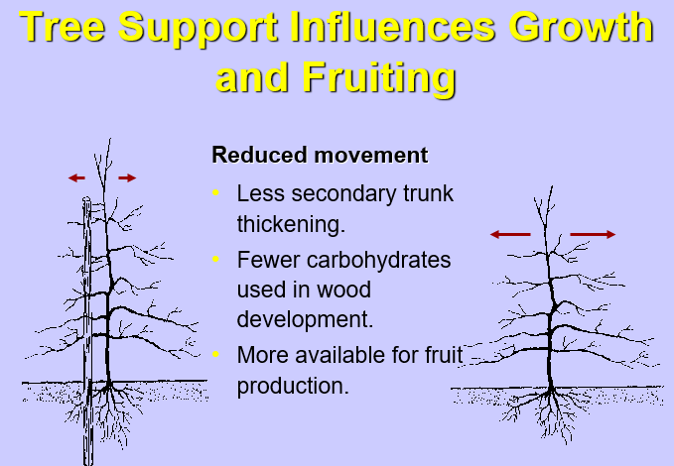
More To Come
The purpose of this handout was to give you an overview of major concepts to consider in pruning fruit trees. Other brief summary handouts will be provided to you at the workshop. After you have finished this overview please peruse the other PDF’s mentioned in the pruning section of the Mercy Acres website, paying special attention to pictures, diagrams, and illustrations and the text corresponding to those visuals. This kind of preparation will maximize your learning in the field during the demonstration.

